**Comprehensive Analysis of Superstore Sales: Revenue Breakdown by Region, State, and Product Category**

**Project Overview**

The dataset includes approximately 22 columns, offering extensive insights into the superstore's sales performance. This project focuses on understanding the total revenue generated, categorizing revenue by regions and states, and identifying the top-selling product categories in each region and state.

**Abstract**

This report provides a detailed analysis of the superstore's sales data, highlighting revenue generation, product performance, and customer demographics. Initial data cleaning was done in Excel, followed by advanced data transformation and visualization in Power BI. The resulting dashboard includes 12 charts, revealing that the West region, especially California, generates the highest revenue. Technology products lead in revenue, while Office Supplies have the highest sales volume. The West region dominates sales across all product categories, with significant demand for Technology and Furniture. The Canon ImageCLASS 2200 Advanced Copier is the top-selling product, indicating a strong market for office equipment. Predominantly, the customer base consists of consumers rather than corporate clients. These insights suggest opportunities to enhance marketing efforts, expand product offerings, and target small businesses and potential corporate clients to drive growth.

**Introduction**

**Problem Statement**

The superstore has extensive sales data but lacks comprehensive analysis to derive actionable insights. Management needs to understand overall revenue performance, identify high-revenue regions and states, and determine top-selling product categories. This analysis is essential for informed decision-making, optimizing inventory, and tailoring marketing strategies to boost sales and profitability.

**Objectives**

* **Total Revenue Analysis:** Calculate and analyze total revenue to understand overall sales performance.
* **Regional and State Revenue Categorization:** Identify high-performing and underperforming areas by breaking down revenue by regions and states.
* **Product Category Analysis:** Determine best-selling product categories in each region and state to understand consumer preferences and trends.
* **Data-Driven Insights:** Provide actionable recommendations to improve sales strategies and operational efficiency.

**Methodology**

**Data Cleaning in Excel**

The dataset, obtained in Excel format, underwent initial cleaning, including removing blank entries, eliminating duplicates, and standardizing text formatting.

**Tools Utilized**

* **Excel:** For initial data cleaning and preparation.
* **Power BI:** For advanced data transformation and dashboard creation.

**Stages of Creating the Dashboard**

**Stage I: Data Cleaning in Excel**

Thorough data cleaning was performed in Excel to ensure consistency and accuracy, preparing the data for further transformation.

**Stage II: Data Transformation in Power Query**

Data from Excel was imported into Power Query within Power BI for further transformation, including:

* Identifying key columns (revenue, product categories, regions, states, customer segments, dates).
* Categorizing data to facilitate effective analysis and visualization.
* Formatting date columns for time-based analysis.

**Stage III: Objectives of the Analysis**

The analysis aimed to create a comprehensive dashboard with the following objectives:

1. Total Revenue by Region
2. Total Revenue by State
3. Total Revenue by Product Category
4. Total Number of Products Sold by Region
5. Total Number of Products Sold by State
6. Total Number of Products Sold by Product Category
7. Percentage of Product Types Sold per Region
8. Revenue Percentage of Product Types per Region
9. Product Categories by Customer Segment
10. Total Number of Product Types Sold per State
11. Total Revenue per Product Name
12. Total Revenue per Customer Segment

**Stage IV: Dashboard Creation**

A user-friendly dashboard was created in Power BI, incorporating pie charts and bar charts to represent various metrics such as total revenue, product sales, and customer segments.

**Conclusion**

A structured approach ensured thorough data preparation and transformation, leading to accurate and meaningful insights. Initial cleaning in Excel established a reliable foundation, while further transformations in Power Query organized the data effectively. The final dashboard in Power BI presented the analysis in an accessible and visually appealing manner, facilitating easy comprehension of insights.

**Results**

The final dashboard visually represents key findings, providing a comprehensive overview of the superstore's sales performance through 12 distinct charts. These charts detail total revenue, product sales, and customer segments across regions and states.

**THE DASHBOARD**

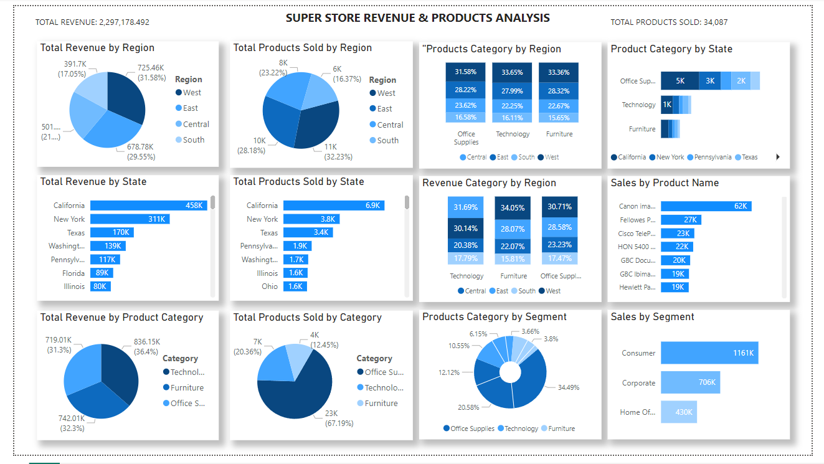

**Key Findings from the Dashboard**

1. **Highest Revenue Region and State:** The West region and California generate the highest revenue.
2. **Top Product Category by Revenue:** Technology products lead in revenue generation.
3. **Product Sales Volume:** The West region has the highest product sales volume.
4. **Sales by Product Category:** Office Supplies account for 67.19% of total sales.
5. **Regional Sales Breakdown:** The West region leads in Office Supplies (31.56%), Technology (33.65%), and Furniture (33.36%).
6. **State-Level Product Sales:** Office Supplies are the most sold category in most states.
7. **Top-Selling Product:** The Canon ImageCLASS 2200 Advanced Copier is the best-selling product.
8. **Customer Segmentation:** The customer base is predominantly consumers rather than corporate clients.

These findings reveal critical trends and opportunities for targeted marketing and inventory management.

**Discussion**

The analysis offers insights into the superstore's market dynamics, guiding future strategies.

**Revenue and Sales Distribution**

The West region is the most lucrative, particularly California. This suggests effective marketing and operational strategies in the West, likely due to higher population density and purchasing power.

**Product Category Insights**

Technology products generate the highest revenue, while Office Supplies account for the highest sales volume. This suggests a need for upselling and cross-selling strategies, leveraging frequent Office Supplies purchases to promote Technology and Furniture products.

**Regional and State Performance**

The West region's balanced demand for diverse products suggests continued emphasis on a wide range of products. The high sales of Office Supplies at the state level indicate a base of small businesses and home offices, suggesting opportunities for targeted deals and loyalty programs.

**Top-Selling Products and Customer Segmentation**

The Canon ImageCLASS 2200 Advanced Copier's high sales highlight the demand for office equipment, suggesting expansion in high-quality office technology products. Predominantly consumer customers indicate potential in developing marketing campaigns for corporate clients.

**Strategic Implications**

1. **Strengthen Marketing in the West:** Focus on marketing in the West region, leveraging the established customer base.
2. **Expand Technology and Office Supplies Offerings:** Drive growth by expanding these high-revenue and high-volume categories.
3. **Target Small Businesses:** Develop strategies for small businesses and home offices to enhance customer retention and increase sales.
4. **Explore Corporate Opportunities:** Attract corporate clients with bulk purchase options and specialized services.

**Understanding Regional Sales Dynamics**

Analyzing regional sales dynamics reveals variations in revenue and product preferences, essential for targeted strategies.

**West Region**

* **Sales Overview:** Highest revenue ($725.46K), contributing 31.58%.
* **Top-Selling Products:** Canon Imageclass and Fellowes Ps-12Cs Shredder.
* **Strategy:** Emphasize premium products in marketing, ensure adequate stock levels.

**East Region**

* **Sales Overview:** Leads in product sales volume (11K), contributing 29.55%.
* **Top-Selling Products:** Cisco TelePresence System and HON 5400 Series Task Chairs.
* **Strategy:** Implement targeted promotions, maintain balanced inventory.

**Central Region**

* **Sales Overview:** Accounts for 21.8% of total revenue.
* **Top-Selling Products:** GBC DocuBind P400 and GBC Laminator.
* **Strategy:** Focus on product bundling and cross-selling, optimize inventory levels.

**South Region**

* **Sales Overview:** Lowest revenue ($391.7K) and product sales (6K).
* **Top-Selling Products:** Hewlett Packard LaserJet and 3M Ergonomic Mouse.
* **Strategy:** Increase market penetration with localized campaigns, manage inventory carefully.

**Overall Strategic Recommendations**

* **Segmented Marketing Campaigns:** Highlight regional top sellers and local preferences.
* **Dynamic Inventory Management:** Adjust stock based on real-time data.
* **Customer Insights and Feedback:** Use feedback to refine products and marketing messages.
* **Data-Driven Decision Making:** Use analytics for product launches and marketing investments.

**Conclusion**

The comprehensive analysis provides valuable insights into the superstore's revenue streams, product performance, and customer segmentation. Focusing on high-performing regions and states, expanding popular product categories, and developing targeted marketing strategies will enhance market presence and drive growth. Understanding regional sales dynamics and top-selling products will be key to achieving sustained growth and competitive advantage.